Variables Worksheet

1. What is a variable?

|  |
| --- |
|  |

1. What kinds of information can a variable store?

|  |
| --- |
|  |

1. What are the rules for naming variables?

|  |
| --- |
| * You should always start variable names with a ______. * You can use _______, ____, and ___________ in the names of your variables. * You should name your variables so that they _______ the values that they store. |

1. Look at the following code. We want to create a program that asks a user for the name of the country that they live in.

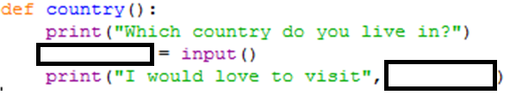

Suggest an appropriate variable name for this code.

|  |
| --- |
|  |